ME 730/MS 830 – Solid solution strengthening

1. Estimate the interaction parameter for Au in Cu from the upper left-hand figure on slide 14 on the Solid Solution PowerPoint (also in the text) assuming that Au is a substitutional solute.
2. Slide 14 shows the dependence of the increase in yield strength as a function of C in Fe. Estimate the magnitude of the γ term in the equation for tetragonal solid solution strengthening. Remember that  .
3. Slide 16 shows stress strain curves for low carbon Fe that were predeformed prior to the tensile test and either tested again right away or tested after aging at an elevated temperature for one hour.
   1. C atoms are tetragonal solutes and the strengthening often depends on them condensing on the dislocations. What carbon concentration is required to have one carbon atom for each plane the dislocation line goes through if the dislocation density is 1012/m2 and 1012/m2? Use interplanar spacing in the [110] for your estimate.
   2. Assume that the dislocations all broke free of their C atmosphere during the prestraining. Estimate the grain size assuming all of the prestrained strength comes from grain size strengthening using ky = 0.74 MN/m3/2 and σ0 = 70 MPa. Estimate the strength contribution from work hardening assuming all of the prestrained strength comes from dislocation back stress.
   3. Using your γ from the previous problem, estimate the carbon concentration vs. aging time.
   4. Explain why the yield strength increases with aging time.
4. 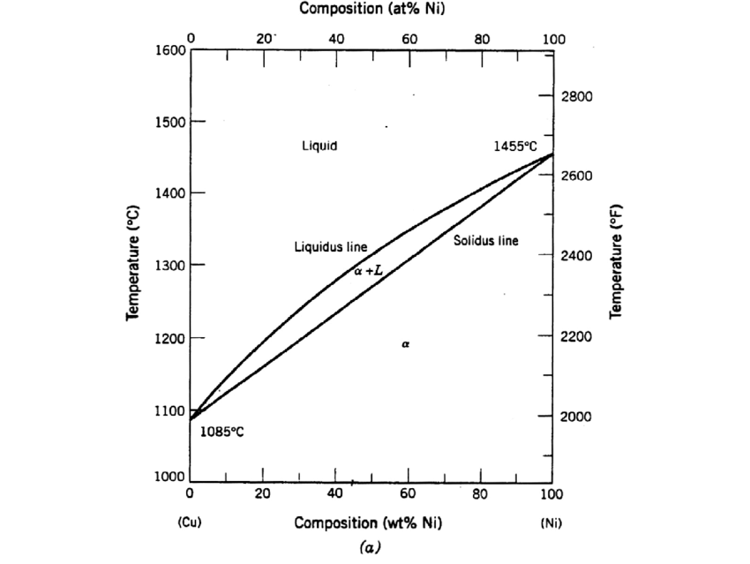Cu and Ni form a continuous substitutional solid solution (see phase diagram to the right). The critical resolved shear stress of pure Cu is 0.48 MPa and the critical resolved shear stress of Ni is 5.7 MPa. The atom size mismatch and modulus mismatch both contribute to substitutional solid solution hardening.
   1. Estimate the modulus misfit parameter for Cu in Ni and for Ni in Cu.
   2. Estimate the size misfit parameter for Cu in Ni and for Ni in Cu.
   3. Estimate the interaction parameter,  for Cu in Ni and for Ni in Cu.
   4. Plot the shear yield stress strengthening increment,  ,as a function of Ni concentration in Cu up to a concentration of 50.